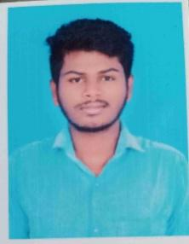

Dinesh D

Phone No : 9080757183

Gmail : [Dineshd4242@gmail.comt](mailto:Dineshd4242@gmail.comt)

Address;

No,1/382

Vaithiyar street Extent,

Thrisulam Ch - 600043

**CAREER OBJETCIVE**

To continuously enhance my knowled ge, skills, and experience by getting involved in challenging environment and untilize them for personal and organizational growth to the best of my ability.

**ACADEMIC QUALIFICATIONS**

|  |  |  |  |
| --- | --- | --- | --- |
| **Exam** | **YEAR** | **NAME**  **OF**  **INSTITUTE** | **PERCENTAGE** |
| **SSLC** | **2019** | **MPL HIGHER SEC SCHOOL**  **STATE BOARD** | **48%** |
| **HSS** | **2022** | **MPL HIGHER SEC SCHOOL**  **STATE BOARD** | **66%** |
| **BCA** | **2023-2026** | **AM JAIN COLLEGE** | **__** |

**PROFESSIONAL QUALIFICATION**

* knowledge of Ms word

* Java

* python

*Ethical hacking

**WORK EXPERIENCE**

**Ipsos research private limited**

As aTeam leader at ipsos

September 2022 to Current

Data analyst

**PERSONAL PROFILE**

**Father Name :** Mr. Devaraj M

**Date of Birth** **:** 29th – March – 2002

**Gender**  **:** Male

**Marital status** **:** Unmarried

**Nationality**  **:** Indian

**Languages Known** **:** Tamil & English

**DECLARATION**

I hereby declare that the above information is true to best of my knowledge.

Date :

Place :

**SIGNATURE**

**DINESH D**